Rip 4 noeds:

1st trial:

ping:

xiangdua@client:~$ ping 192.168.20.10

PING 192.168.20.10 (192.168.20.10) 56(84) bytes of data.

64 bytes from 192.168.20.10: icmp_req=1 ttl=61 time=3.68 ms

64 bytes from 192.168.20.10: icmp_req=2 ttl=61 time=3.04 ms

64 bytes from 192.168.20.10: icmp_req=3 ttl=61 time=2.59 ms

64 bytes from 192.168.20.10: icmp_req=4 ttl=61 time=2.97 ms

64 bytes from 192.168.20.10: icmp_req=5 ttl=61 time=2.37 ms

traceroute:

xiangdua@client:~$ traceroute 192.168.20.10

traceroute to 192.168.20.10 (192.168.20.10), 30 hops max, 60 byte packets

1 router-1-lan5 (192.168.10.10) 0.782 ms 0.746 ms 0.713 ms

2 router-4-lan3 (192.168.4.1) 1.264 ms 1.250 ms 1.218 ms

3 router-3-lan2 (192.168.3.2) 1.635 ms 1.614 ms 1.584 ms

4 server-lan6 (192.168.20.10) 2.182 ms 2.158 ms 2.127 ms

iperf:

client tcp:

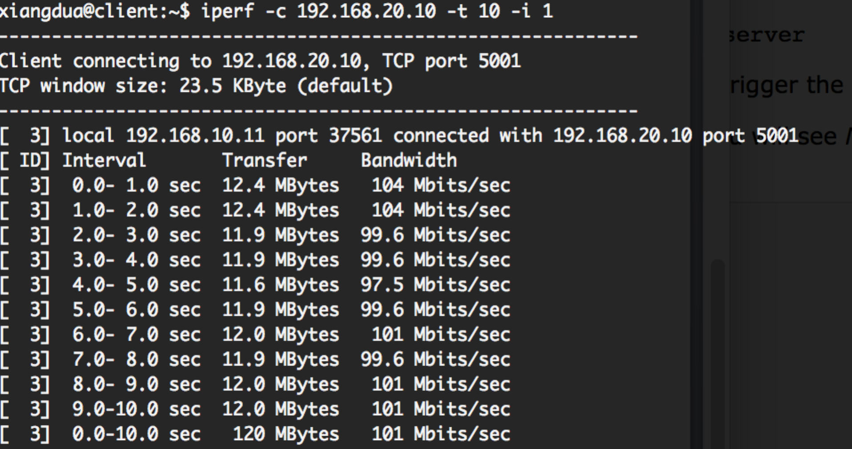

server tcp:

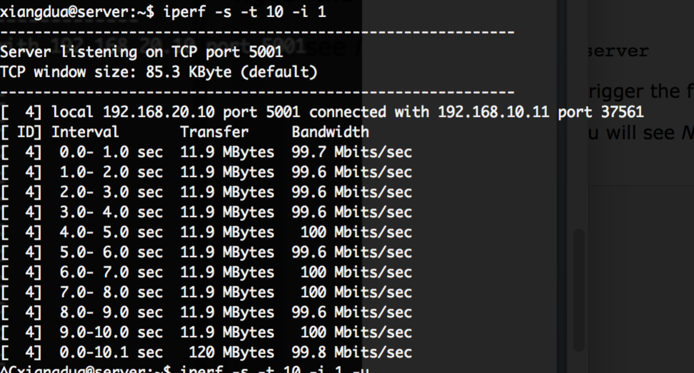

client udp:

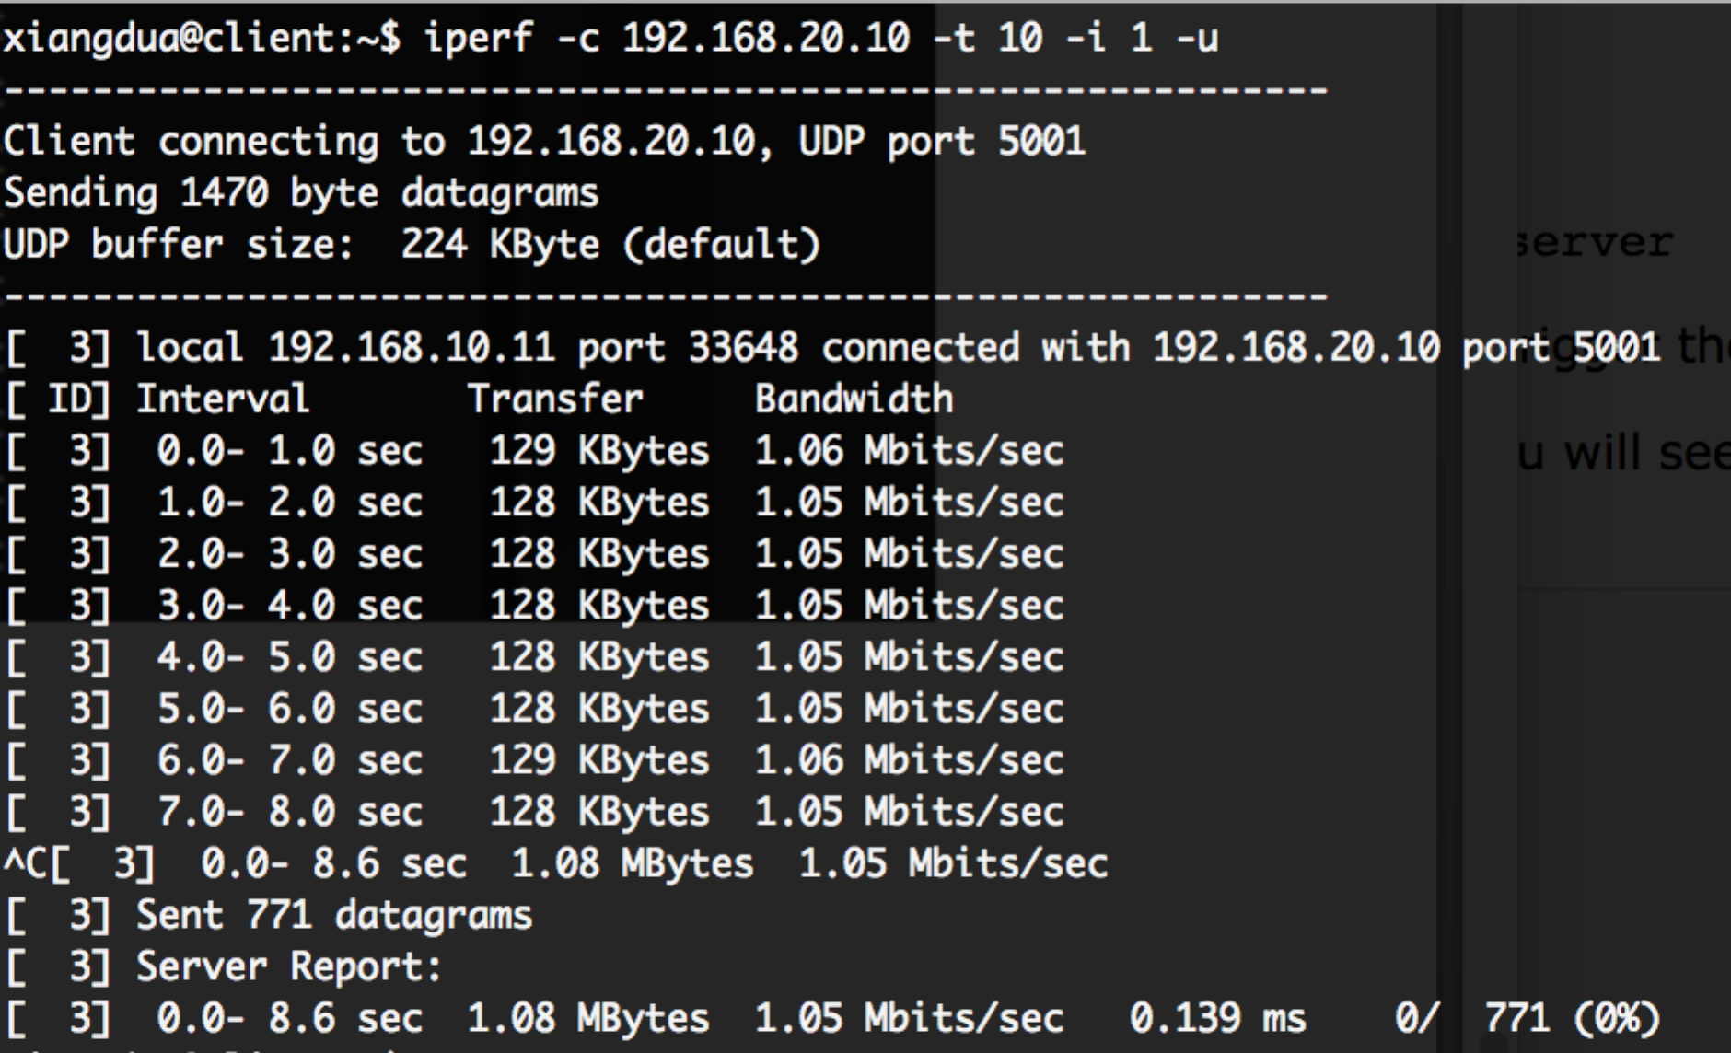

server udp:

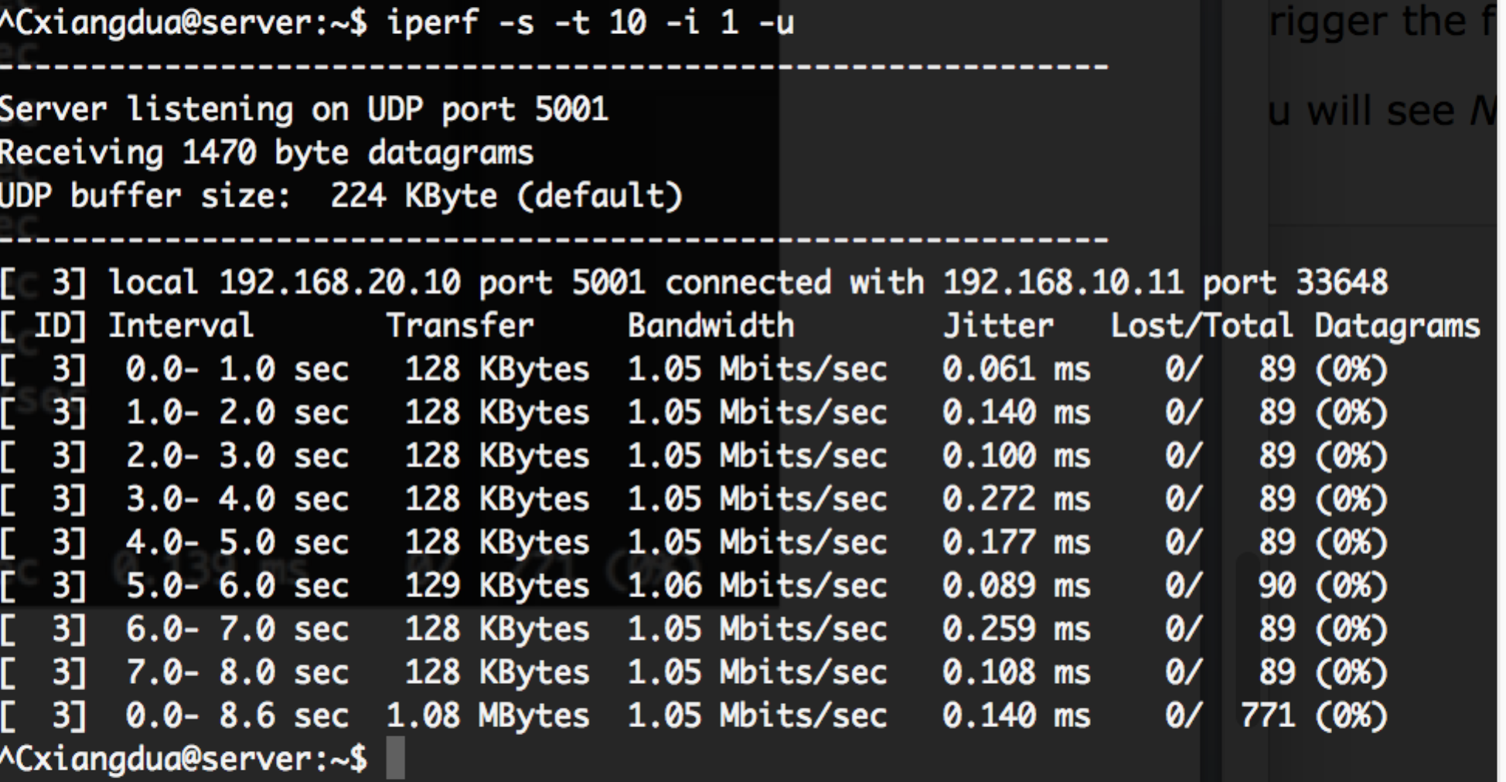

routing table:

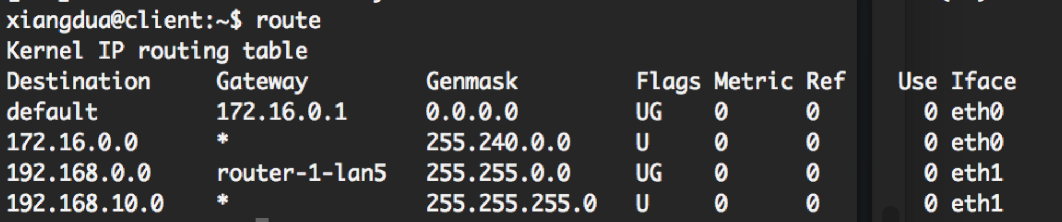

2nd trial:

ping:

xiangdua@client:~$ ping 192.168.20.10

PING 192.168.20.10 (192.168.20.10) 56(84) bytes of data.

64 bytes from 192.168.20.10: icmp_req=1 ttl=61 time=5.35 ms

64 bytes from 192.168.20.10: icmp_req=2 ttl=61 time=2.25 ms

64 bytes from 192.168.20.10: icmp_req=3 ttl=61 time=1.62 ms

64 bytes from 192.168.20.10: icmp_req=4 ttl=61 time=2.41 ms

64 bytes from 192.168.20.10: icmp_req=5 ttl=61 time=1.94 ms

64 bytes from 192.168.20.10: icmp_req=6 ttl=61 time=1.67 ms

traceroute:

xiangdua@client:~$ traceroute 192.168.20.10

traceroute to 192.168.20.10 (192.168.20.10), 30 hops max, 60 byte packets

1 router-1-lan5 (192.168.10.10) 0.720 ms 0.681 ms 0.877 ms

2 router-2-lan0 (192.168.1.2) 1.314 ms 1.298 ms 1.266 ms

3 router-3-lan2 (192.168.3.2) 1.919 ms 1.899 ms 1.868 ms

4 server-lan6 (192.168.20.10) 2.249 ms 2.222 ms 2.242 ms

iperf

client tcp

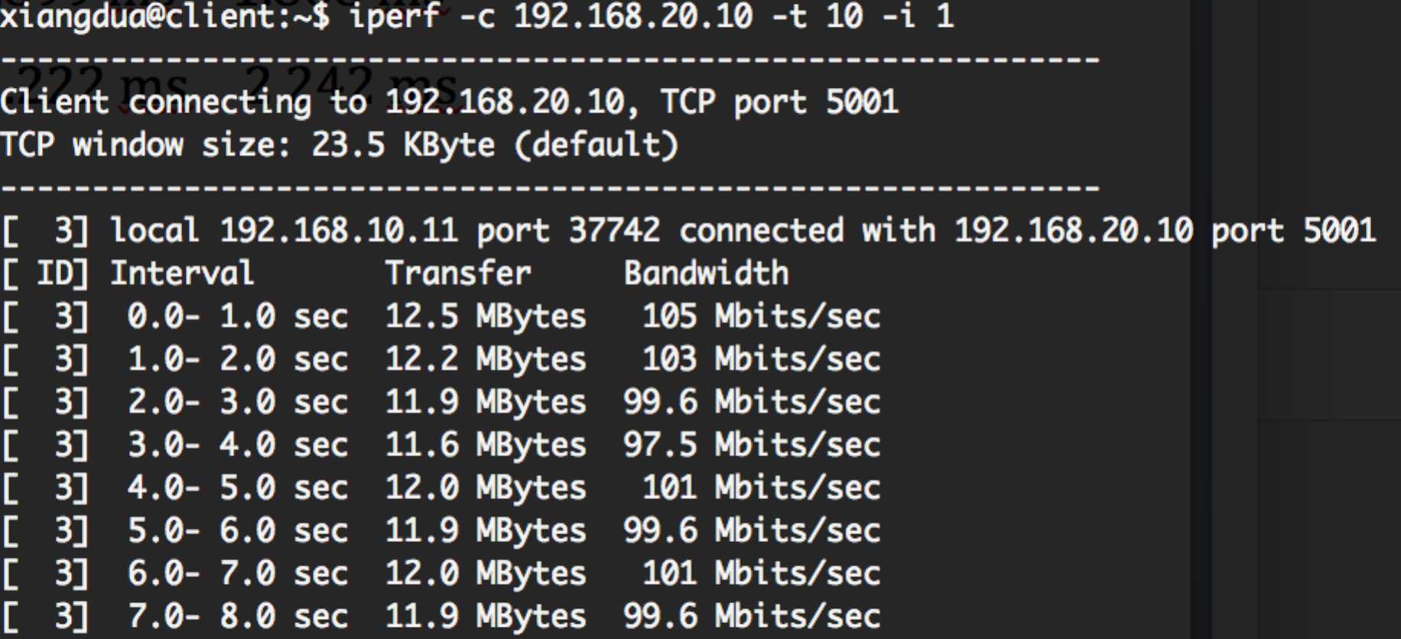

server tcp:

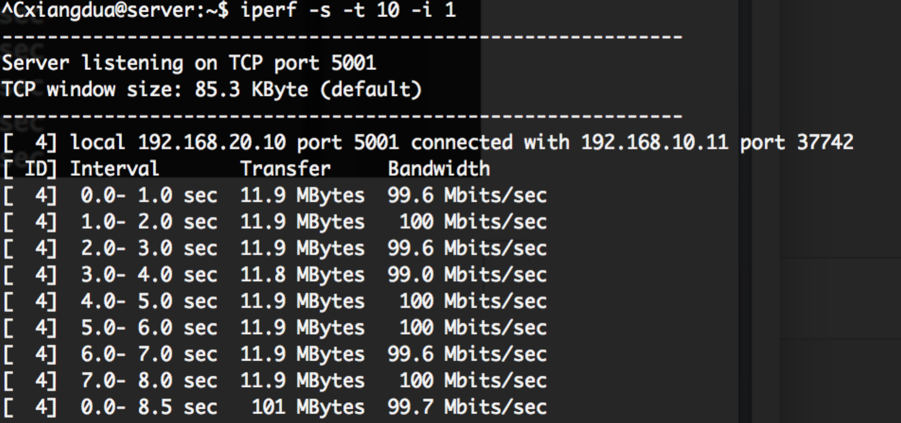

client udp:

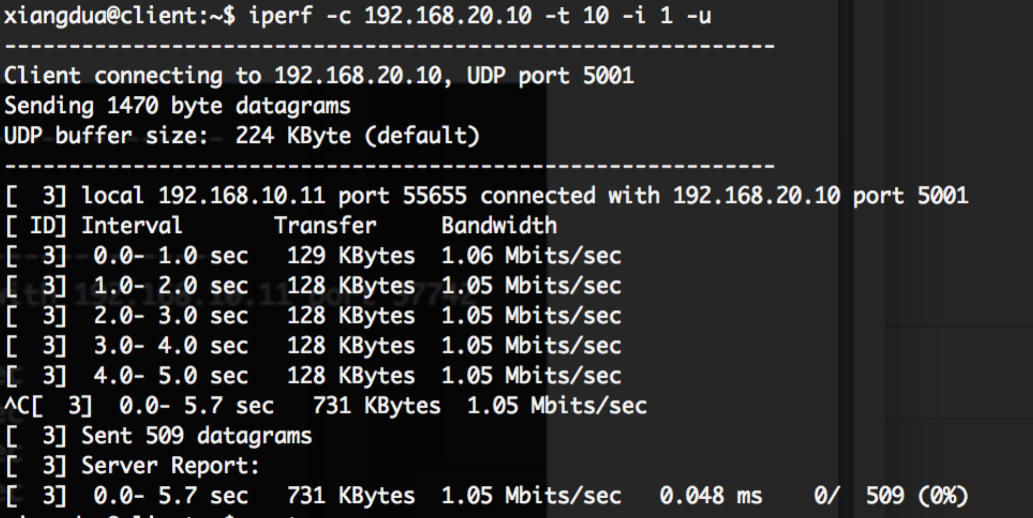

server udp:

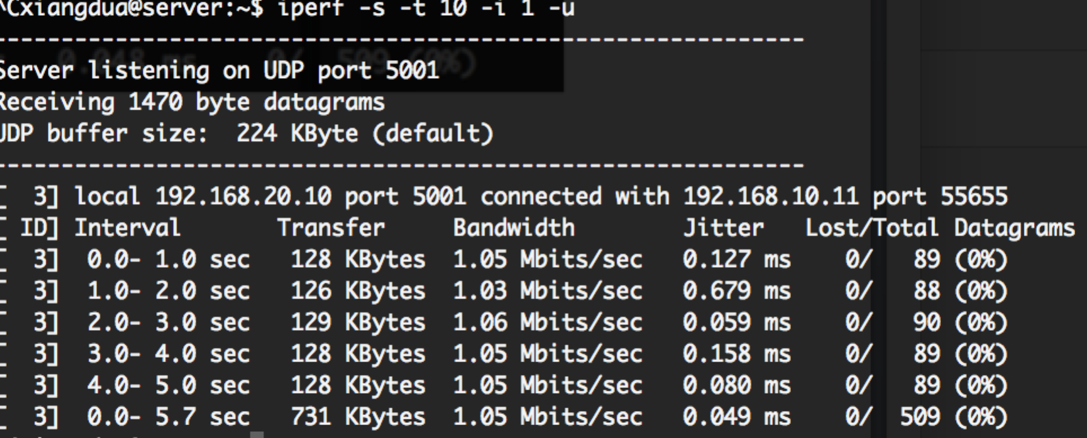

routing table:

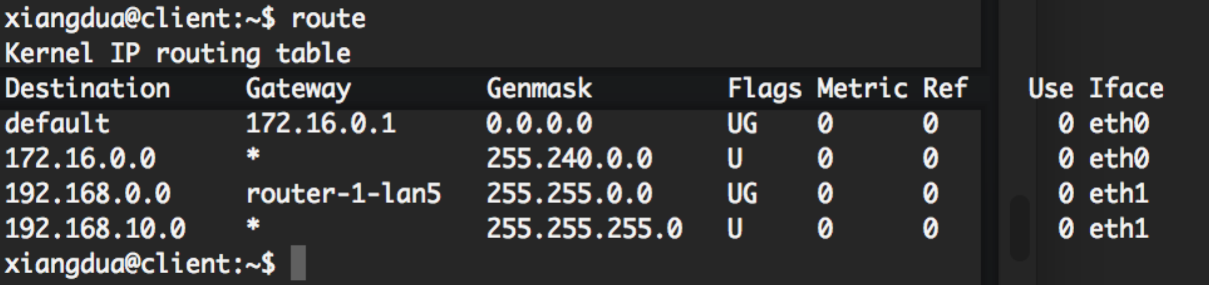

3rd trial:

ping:

xiangdua@client:~$ ping 192.168.20.10

PING 192.168.20.10 (192.168.20.10) 56(84) bytes of data.

64 bytes from 192.168.20.10: icmp_req=1 ttl=61 time=2.94 ms

64 bytes from 192.168.20.10: icmp_req=2 ttl=61 time=2.99 ms

64 bytes from 192.168.20.10: icmp_req=3 ttl=61 time=3.01 ms

64 bytes from 192.168.20.10: icmp_req=4 ttl=61 time=2.84 ms

64 bytes from 192.168.20.10: icmp_req=5 ttl=61 time=2.00 ms

64 bytes from 192.168.20.10: icmp_req=6 ttl=61 time=2.13 ms

traceroute:

xiangdua@client:~$ traceroute 192.168.20.10

traceroute to 192.168.20.10 (192.168.20.10), 30 hops max, 60 byte packets

1 router-1-lan5 (192.168.10.10) 0.656 ms 0.606 ms 0.573 ms

2 router-2-lan0 (192.168.1.2) 0.940 ms 0.912 ms 0.916 ms

3 router-3-lan2 (192.168.3.2) 1.746 ms 1.720 ms 1.689 ms

4 server-lan6 (192.168.20.10) 2.202 ms 2.178 ms 2.195 ms

iperf

client tcp

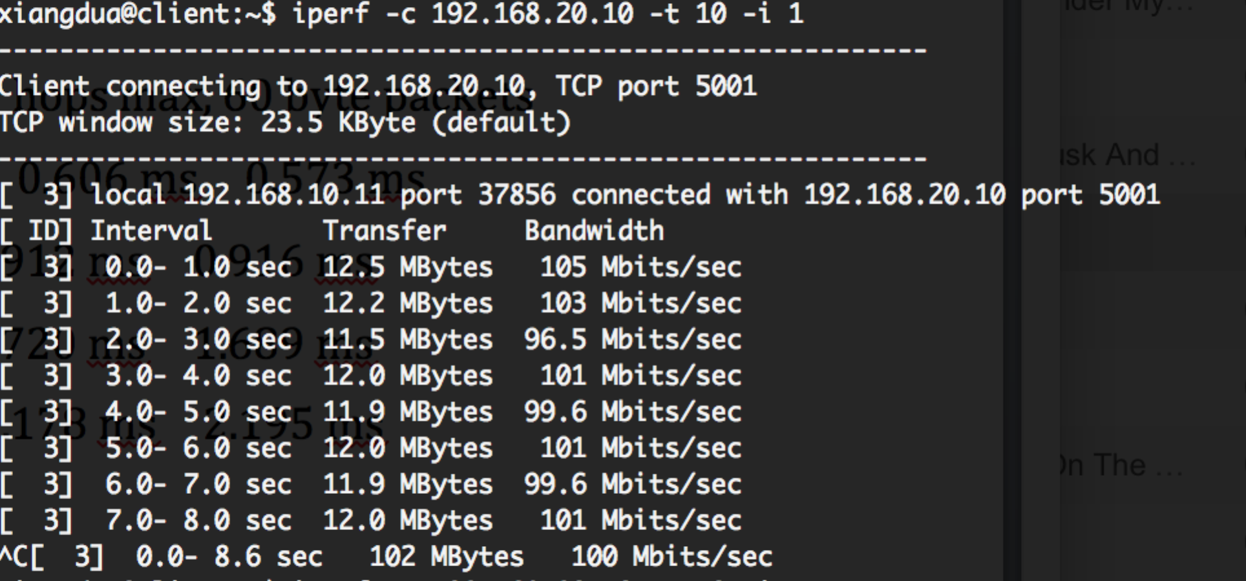

server tcp

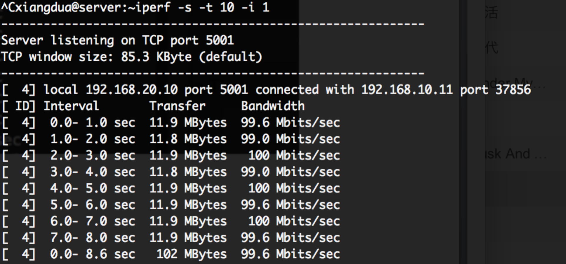

client udp

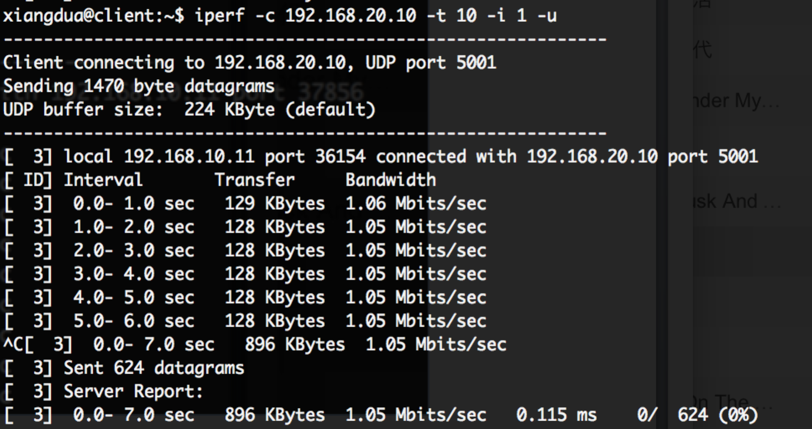

server udp

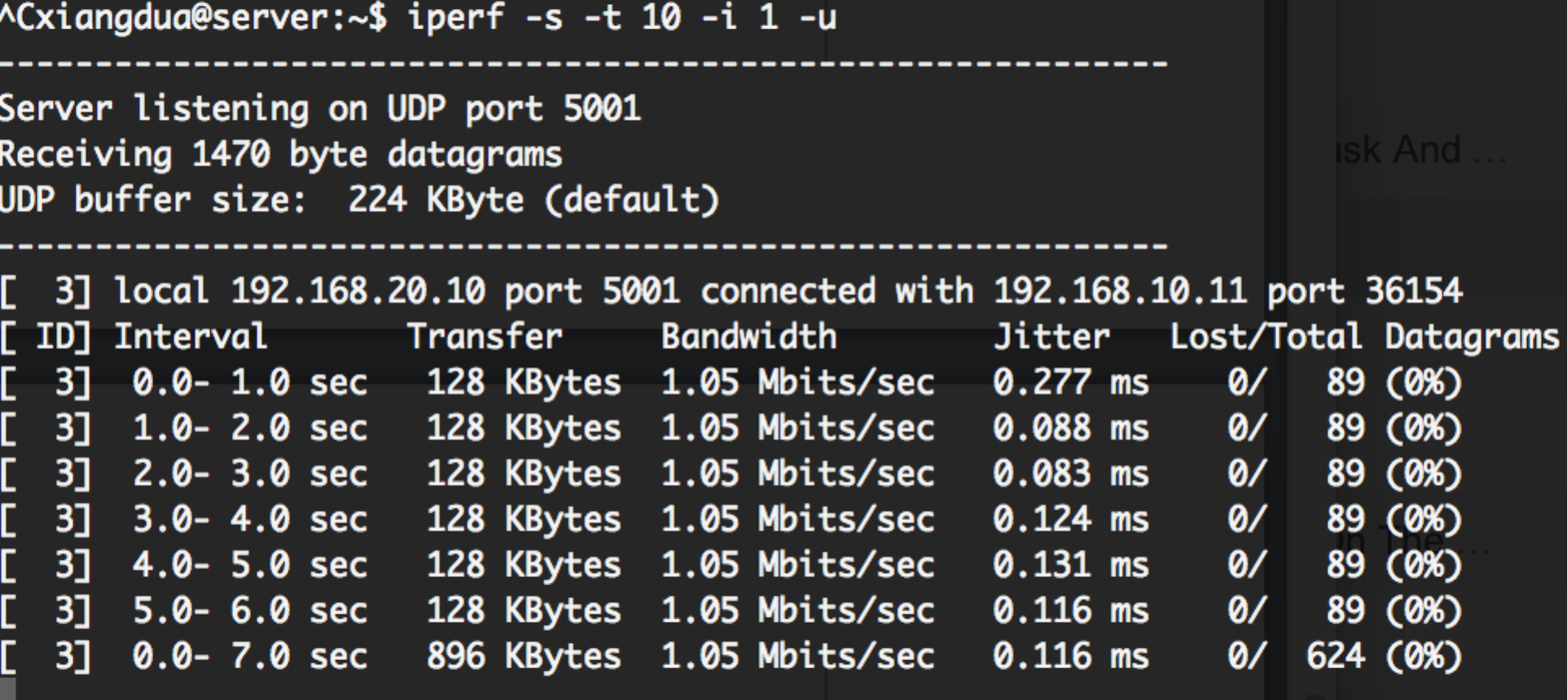

route:

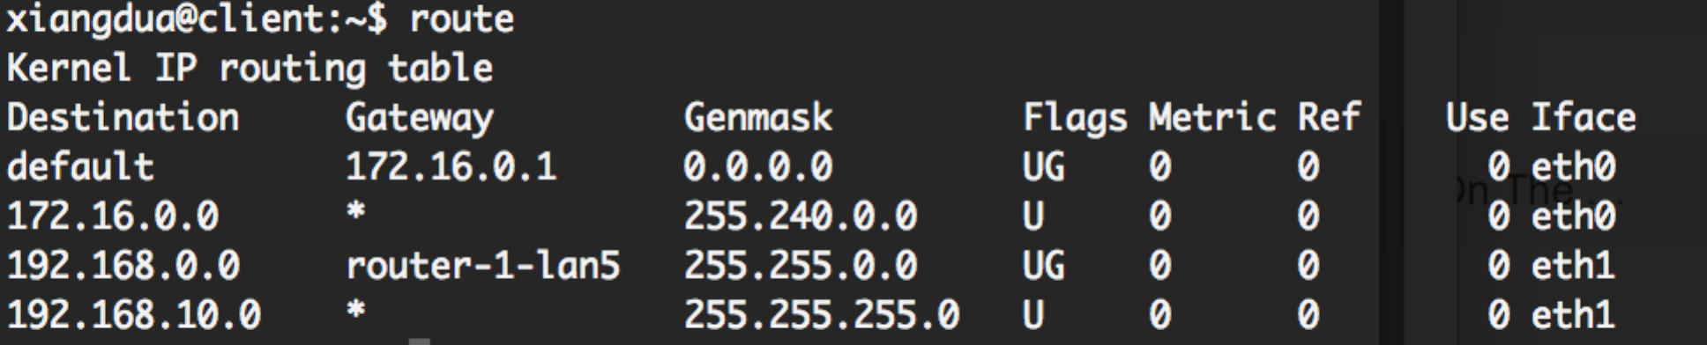

**bring down eth1 at router2:**

traceroute:

xiangdua@client:~$ traceroute 192.168.20.10

traceroute to 192.168.20.10 (192.168.20.10), 30 hops max, 60 byte packets

1 router-1-lan5 (192.168.10.10) 0.721 ms 0.669 ms 0.637 ms

2 router-4-lan3 (192.168.4.1) 1.478 ms 1.451 ms 1.436 ms

3 router-3-lan2 (192.168.3.2) 1.703 ms 1.711 ms 1.723 ms

4 server-lan6 (192.168.20.10) 2.103 ms 2.066 ms 2.039 ms

route:

